# How to burn a bootloader

// Use: ArduinoISP.ino in this folder

// Use AVR ISP Shield board from AliExpress

// 1. Select correct COM port

// 2. Select board: Arduino/Genuino Uno

// 3. Select Programmer: Arduino as ISP

// 4. Sketch -> upload

// 5. Insert new Arduino

// 6. Tools -> Burn Bootloader

// 7. insert new Arduino and burn bootloader again

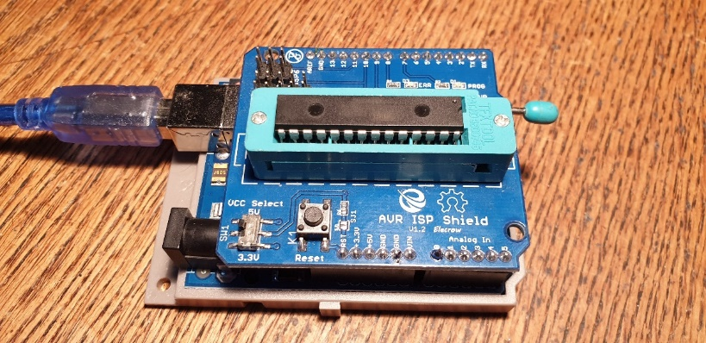

# How to download a sketch to the Arduino chip

## Buy USB to serial device

AliExpress: FT232RL FTDI USB 3.3 V 5.5 V, USB naar TTL Seriële Adapter voor Arduino

See also: <http://auseparts.com.au/index.php?route=product/product&product_id=333>

## Connect to Arduino

RX on this board to the TX pin on your device  
TX on this board to the RX pin on your device  
GND on this board to GND on your device

5V on this board to 5V on your device

Connect DTR via a capacitor of 100 nF with the Reset pin of the Arduino.

Connect resistor of 10k from Reset pin to 5V.

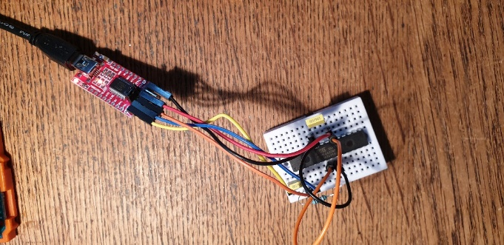

## Download sketch

* select board configuration: "ATmega328 on a breadboard (8 MHz internal clock)"
* Select baudrate. No programmer need to be selected.
* Upload your sketch